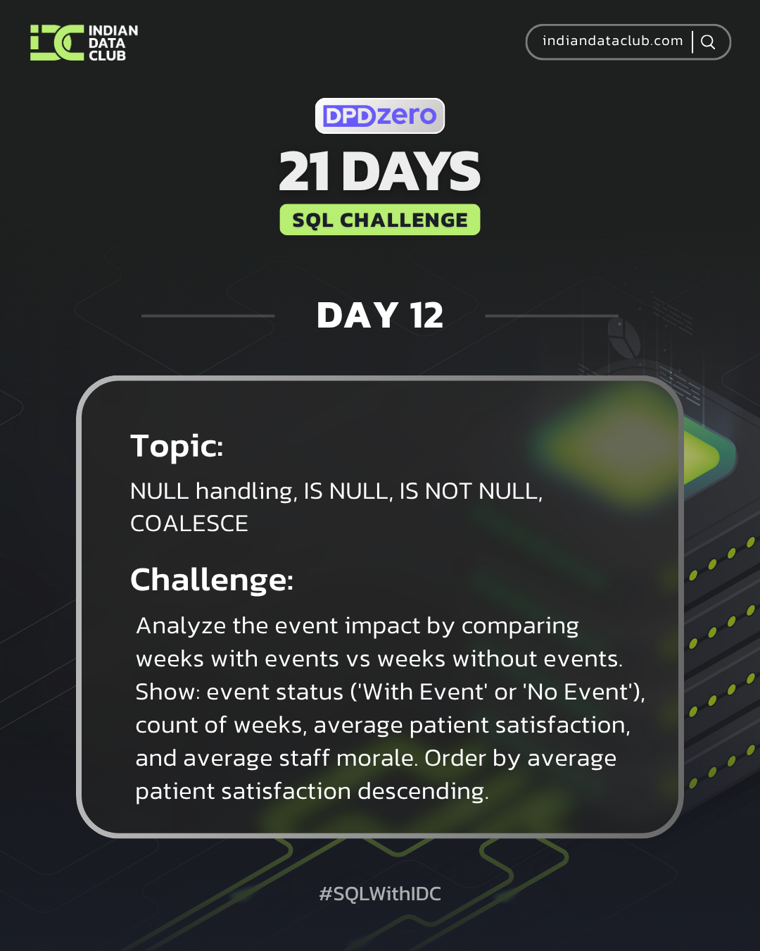
Day-12 SQL Challenge
Day-12 Challenge:
Analyze the event impact by comparing weeks with events vs weeks without events. Show: event status ('With Event' or 'No Event'), count of weeks, average patient satisfaction, and average staff morale. Order by average patient satisfaction descending.
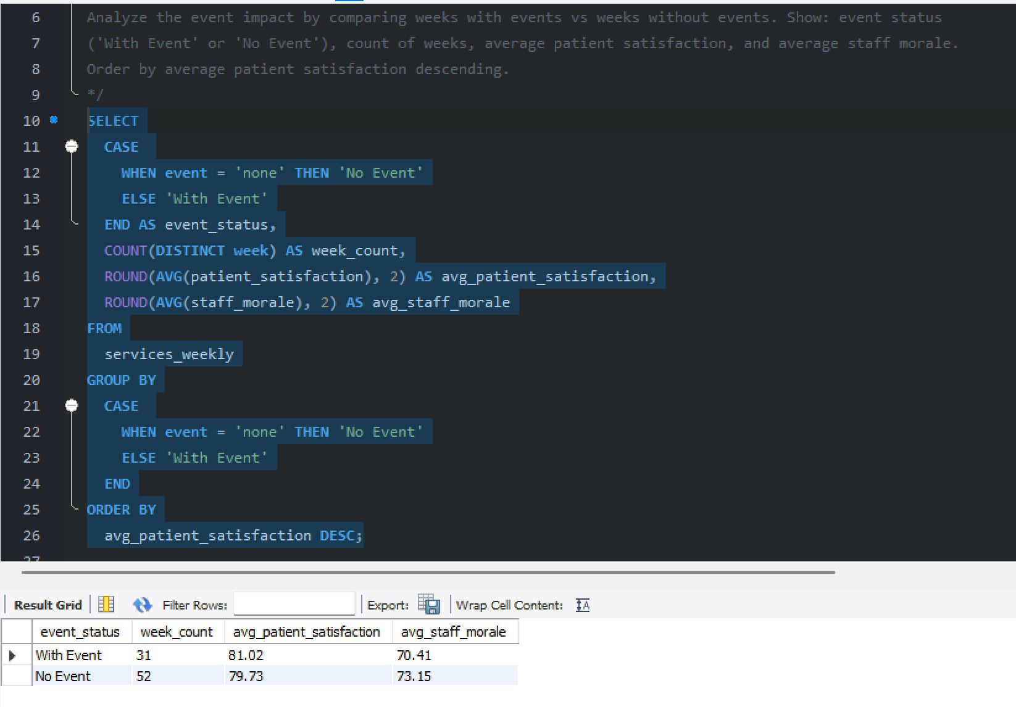

Practice Questions:
1. Find all weeks in services_weekly where no special event occurred.
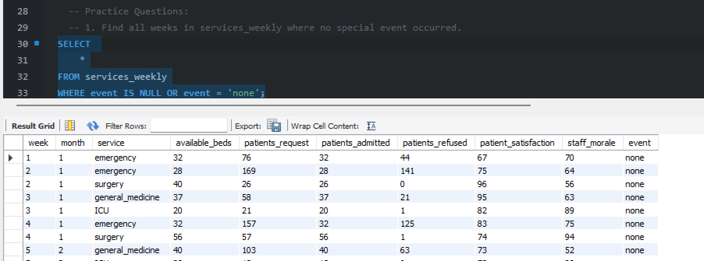
2. Count how many records have null or empty event values.
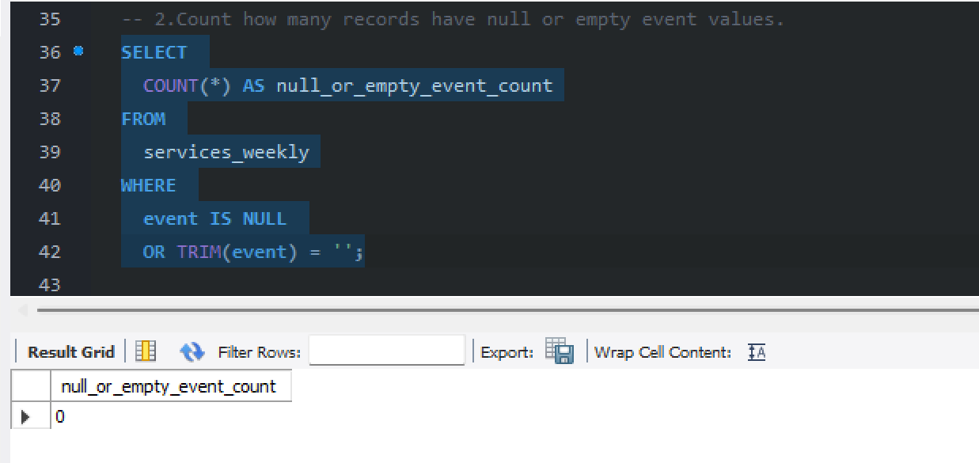

3. List all services that had at least one week with a special event.
